**PROJECT REPORT**

ON

“ZIGBEE BASED WIRELESS SENSOR NETWORK”

Submitted in partial fulfilment of the requirements for the award of degree of

**BACHELOR OF ENGINEERING**

IN

**ELECTRONICS AND COMMUNICATION ENGINEERING**



**VISVESVARAYA TECHNOLOGICAL UNIVERSITY, BELGAUM**

SUBMITTED BY:

**ANANDAKUMAR R C 1BM11EC402**

**MANJUNATHA REDDY T 1BM11EC411**

**MANJUNATHA N 1BM11EC412**

**PHILEMON CHAWANG NG 1BM10EC070**

Under the Guidance of,

R C Radha

Assistant Professor, ECE Dept., BMSCE



Department of Electronics and Communication Engineering

**B.M.S COLLEGE OF ENGINEERING**

(Autonomous College Affiliated to Visvesvaraya Technological University, Belgaum)

Bull Temple Road, Basavanagudi, Bangalore-560019

**B.M.S COLLEGE OF ENGINEERING**

(Autonomous College under VTU)

**Department of Electronics and Communication Engineering**



**CERTIFICATE**

This is to certify that the project entitled **“ZIGBEE BASED WIRELESS SENSOR NETWORK”** is a bonafide work carried out by **ANANDAKUMAR R C, MANJUNATHA REDDY T,MANJUNATHA N & PHILEMON CHAWANG NG** in partial fulfillment for the award of Bachelor of Engineering degree by VTU Belgaum, during the academic year 2013-2014.

Internal Guide HOD,ECE,BMSCE Principal, BMSCE

**R C Radha Dr.D.Seshachalam** **Dr.K.Mallikarjuna**

**External Examination:**  **Signature with date:**

1**.**

2.

# ACKNOWLEDGEMENT

Any achievement, be it scholastic or otherwise does not depend solely on the individual efforts but on the guidance, encouragement and cooperation of intellectuals, elders and friends. A number of personalities, in their own capacities have helped us in carrying out this project work. We would like to take this opportunity to thank them all.

We express profound gratitude to respected principal **Dr.K. Mallikharjuna Babu,** BMS College of Engineering for providing a congenial environment to work in.

Our sincere gratitude to **Dr. D. Seshachalam,** Head of the Department, Electronics and Communication Engineering for encouraging and providing this opportunity to carry out the project in the department.

We would like to thank our guide **R C Radha,** Assistant Professor, Department of ECE and also **Harish V Mekali,** Assistant Professor, Department of ECE who helped us in all the ways to carry out the project work. They stood beside and guided us in every step.

We are very much thankful to our collage BMSCE for sponsoring the project.We would like to share the joy completing the project to all the team members of NXP lab**.**

We thank all our professors for providing the basic knowledge without which this project wouldn't have been possible. Last but not the least we thank our family and friends, who made their valuable support compelled us to maintain a standard throughout our endeavour.

# ABSTRACT

The Wireless technologies continue to find increasing applications in the home and industrial environments. Many home and industrial applications need low data rates for control purposes. Data acquisition and its transfer, building automation and security are the newer applications. It is desirable that the wireless sensors deployed for such applications have long battery lives. As an open and global standard for WSN, ZigBee shows advantages on low-cost, low power consumption and self-forming. The current researches of ZigBee wireless sensor network on industrial automation, electronic products, smart buildings and medical care were presented and protected agriculture overcoming the limits of wire connection, its applied design for greenhouse management was proposed by introducing both the hardware and software architectures. The node power consumption was also discussed.

ZigBee is a new wireless network standard for sensor network. The recent release of standards in the field, such as IEEE 802.15.4and ZigBee, brought the technology out of research labs and stimulated the development of numerous commercial products. Moving from early research in military applications, sensor networks now are widely deployed in diverse applications including home automation, building automation, and utility metering, floods monitoring, rainfall sensing, healthcare. Although many early sensor networks used proprietary routing algorithms and RF technology, most recent products use standards-based networking and RF solutions. A key enabling standard for much of the commercial activity in the wireless sensor network area is the IEEE 802.15.4 standard.

# LITERATURE SURVEY

The following literatures were studied and the ideas and limitations were considered for the development of our project.

2.1 The Application Research of Wireless Sensor Network Based on ZigBee by Changjiang Li., Yufen Wang., XiaojuanGuo.

1. The sensor network is one new research area of computer science technology and has the widespread application prospect.
2. The sensor network's characteristic proposes to us a series of challenging question. The wireless sensor node must have corresponding wireless network protocol including MAC level, router level, network level and application layer to carry on mutual data exchange, the traditional wireless protocol is very difficult to adapt the request of low expenditure, low energy of wireless sensor network, in this situation, ZigBee protocol emerges as the times require.
3. ZigBee technology is one kind of bidirectional wireless communication or wireless network technology of short distance, low complexity, low power consumption, low data rate, low cost and is a group of technology about network, security and application software of 802.15.4 wireless standard development based on the IEEE authorization.

2.2. ZigBee Based Wireless Sensor Networks and Its Applications in Industrial. By ; Shizhuang Lin, Jingyu Liu and Yanjun Fang

1. Recently, advances in micro-electro-mechanical systems (MEMS) technology, wireless communications, and digital electronics have enabled the development of low-cost, low power multifunctional sensor nodes that are small in size and communicate untethered in short distances. Based on the collaborative effort of a large number of these tiny sensor nodes, Wireless sensor network (WSN) system is autonomous and operate unattended, adaptive to the environment.
2. ZigBee is a new standard intended for low cost devices in automation, home controls and computer peripherals. It enables the broad-based deployment of wireless networks with low cost, low power solutions
3. Knowledge on the design mainly consisting of wireless sensor network and wireless information unit that’s based on Zigbee technology and concentrated on low power consumption.

2.3 Wireless Technology: Overcoming Obstacles

By BOM Editorial Staff - May 2007 - [Power & Communication](http://www.facilitiesnet.com/powercommunication)

1. The use of wireless systems is not always straightforward. Some wireless technologies use a significant amount of power — so much so that batteries must be changed frequently, creating a potential maintenance hassle. And then there are concerns about the reliability of wireless networks.
2. A wireless standard known as ZigBee is designed specifically to address those concerns.
3. One of ZigBee’s greatest advantages, according to Ravi Sharma, marketing director for Ember. “ZigBee’s greatest virtue as an application is its ability to dramatically reduce energy consumption and energy waste,” he says.
4. “ZigBee devices can run unattended for years on cheap batteries,” says Sharma. “Other power-hungry wireless standards would be extremely high-maintenance in sensor network applications.”

# SPONSOR DETAILS

We are very much thankful to Visvesvaraya Technological University for funding the entire project.



# TABLE OF CONTENTS

### INTRODUCTION

### HARDWARE

#### ZIGBEE CONFIGARATION

#### 4. BLOCK DIAGRAM

#### 5. FINAL WORKING MODEL

### 6. SOFTWARE

### 7. SCHEMATIC

8. CONCLUSION

9. FUTURE WORK

### ANNEXURE A- DATA SHEETS OF DEVELOPMENT BOARD CORTEX

### ANNEXURE B- DATA SHEETS OF TARANG MODULE F4

### ANNEXURE C- DATA SHEETS OF MOISTURE SENSOR

# INTRODUCTION

A **wireless sensor network (WSN)** consists of spatially distributed [autonomous](http://en.wikipedia.org/wiki/Autonomous) [sensors](http://en.wikipedia.org/wiki/Sensor) to monitor physical or environmental conditions, such as temperature, sound, [pressure](http://en.wikipedia.org/wiki/Pressure), etc. and to cooperatively pass their data through the network to a main location. The more modern networks are bi-directional, also enabling control of sensor activity. The development of wireless sensor networks was motivated by military applications such as battlefield surveillance; today such networks are used in many industrial and consumer applications, such as industrial process monitoring and control, machine health monitoring, and so on.

The WSN is built of "nodes" – from a few to several hundreds or even thousands, where each node is connected to one (or sometimes several) sensors. Each such sensor network node has typically several parts: a [radio](http://en.wikipedia.org/wiki/Radio) [transceiver](http://en.wikipedia.org/wiki/Transceiver) with an internal [antenna](http://en.wikipedia.org/wiki/Antenna_(radio)) or connection to an external antenna, a [microcontroller](http://en.wikipedia.org/wiki/Microcontroller), an electronic circuit for interfacing with the sensors and an energy source, usually a [battery](http://en.wikipedia.org/wiki/Battery_(electricity)) or an embedded form of [energy harvesting](http://en.wikipedia.org/wiki/Energy_harvesting). A [sensor node](http://en.wikipedia.org/wiki/Sensor_node) might vary in size from that of a shoebox down to the size of a grain of dust, although functioning "motes" of genuine microscopic dimensions have yet to be created. The cost of sensor nodes is similarly variable, ranging from a few to hundreds of dollars, depending on the complexity of the individual sensor nodes. Size and cost constraints on sensor nodes result in corresponding constraints on resources such as energy, memory, computational speed and communications bandwidth. The topology of the WSNs can vary from a simple star network to an advanced multi-hop wireless mesh network. The propagation technique between the hops of the network can be routing or flooding.

The concept of wireless sensor networks is based on a simple equation: Sensing + CPU + Radio = Thousands of potential applications. Sensor nodes are of the combination of sensing and special purpose computing devices tied with wireless communications. When networked, such sensor nodes would build up the part of larger systems, providing data, as well ZigBee based wireless sensor networks have tremendous usage potential, because they are much more flexible in both installation and running operation mode than conventional wired networks. ZigBee wireless networks are adaptive and self-healing, that means these networks can withstand even hostile changes in the environment, like devices leaving the network due to hardware malfunctions or electromagnetic interferences. The ZigBee specification puts very much emphasis on battery power conservation all the layers (physical, Media Access Control (MAC), network and application) from the ground up (IEEE 802.15.4) support this most important goal. The standard specifies that a ZigBee End Device (ZED) must be able to operate at a minimum for 2 years on a single battery cell. [1] The transmission is low data rate, that means that while the maximum theoretical throughput between two devices can be up to around 250 kbps.

.

# 2. HARDWARE

## 2.1 ARM CORTEX M3

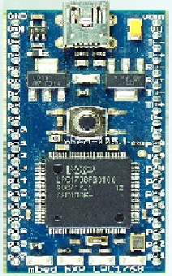

It is a 32bit microcontroller developed by NXP forward by ARM architecture. British computer manufacturer Acron computers first developed ARM in the 1980s to use in its personal computers. Its first ARM-based products were coprocessor modules for the Micro series of computers. Designed for real time real time application, specifically designed to enable partners to develop high performance low cost devices. Generally used in automotive, industrial control systems, wireless systems etc. It is low power consumption device.

FIGURE 3.1

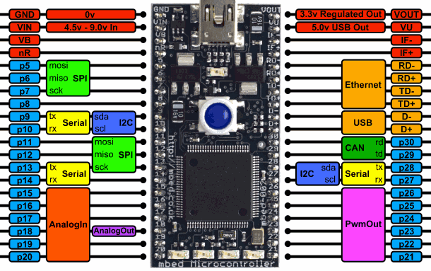

FIGURE 3.2

### 2.1.1. KEY FEATURES

* Frequency of operation is 150Mhz
* 40pin microcontroller
* Built in memory protection
* Flash memory of 2MB
* Tick timer
* 200 kB SRAM for code and data use
* 32 kB ROM containing boot code and on-chip software driver
* Crystal oscillator with an operating range of 1 MHz to 25 MHz
* One high-speed USB 2.0 host/device/OTG interface with DMA

2.1.2 SERIAL INTERFACE

* + - * USB 2.0 full-speed device controller.
      * USART (Universal Synchronous Asynchronous Receiver/Transmitter) with fractional baud rate generation, internal FIFO, a full modem control handshake interface, and support for RS-485/9-bit mode and synchronous mode. USART supports an asynchronous smart card interface (ISO 7816-3).
      * Two SSP (Synchronous Serial Port) controllers with FIFO and multi-protocol capabilities.
      * I2C-bus interface supporting the full I2C-bus specification and Fast-mode Plus with a data rate of up to 1 Mbit/s with multiple address recognition and monitor mode.

## 2.2. ZIGBEE

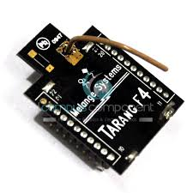 ZigBee is a low-cost, low-power, wireless mesh network standard. The low cost allows the technology to be widely deployed in wireless control and monitoring applications. Low power usage allows longer life with smaller batteries. Mesh networking provides high reliability and more extensive range. ZigBee chip vendors typically sell integrated radios and

Microcontrollers with between 60 KB and 256 KB flash memory. ZigBee operates in the industrial, scientific and medical (ISM) radio bands: 868 MHz in Europe, 915 MHz in the USA and Australia and 2.4 GHz in most jurisdictions worldwide. Data transmission rates vary from 20 kilobits/second in the 868 MHz frequency band to 250 kilobits/second in the 2.4 GHz frequency band.

The ZigBee network layer natively supports both star and tree typical networks, and generic mesh networks. Every network must have one coordinator device, tasked with its creation, the control of its parameters and basic maintenance. Within star networks, the coordinator must be the central node. Both trees and meshes allows the use of ZigBee routers to extend communication at the network level.

We are using Tarang modules are designed with low to medium transmit power and for high reliability wireless networks. The modules require minimal power and reliable delivery of data between devices. The interfaces provided with the module help to directly fit into many industrial applications.

ZigBee builds upon the physical layer and media access control defined in IEEE standard 802.15.4 (2003 version) for low-rate WPANs which is shown in fig below.

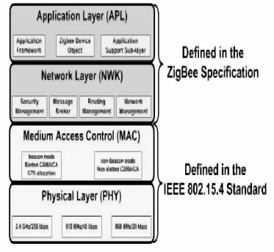

## Features and Benefits:

* Point to point, point to multi point, Mesh and peer-to-peer topologies on proprietary stack.
* Direct Sequence Spread Spectrum technology.
* Each direct sequence channel has 64K unique network addresses.
* Transmit Power: 0 dBs
* RF data rate: 250 kbps.
* Acknowledgement mode communication with retries.
* Power saving modes.
* Source / destination addressing.
* Unicast and broadcast communication.
* Analog to digital conversion and digital I/O line support.
* Default configuration for ready to use.

## Specifications:

# Power

|  |  |
| --- | --- |
| Supply Voltage | 3.3 to 3.6V |
| Transmit Current | 45mA |
| Idle/Receive Current | 50mA |
| Power-down Current | <10 µA |

# General

|  |  |
| --- | --- |
| Rating Frequency | ISM 2.4 - 2.4835 GHz |
| Maximum Transmit Power Output | 1mW (+0 dBm) |
| RF Data Rate | 250 kbps |
| Receiver Sensitivity | -92 dBm |
| Serial Interface Data Rate | Up to 115200 baud |
| Operating Temperature | -40 to 85 °C |
| Antenna Options | Chip Antenna, Wire Antenna |
| Antenna Connector | MMCX |

# Network

|  |  |
| --- | --- |
| Supported Network Topologies | Peer-to-peer, point to multipoint & Mesh |
| Number Of Channels | 16 direct sequence channels |
| Addressing Options | PAN ID, Channel and addresses |

# Mechanical

|  |  |
| --- | --- |
| Dimensions | 37mm x 26mm. |
| Interface Connector | 20 pin receptacles, 2.00mm pitch. |

The specification goes on to complete the standard by adding four main components: network layer, application layer, ZigBee device objects (ZDOs) and manufacturer-defined application objects which allow for customization and favor total integration.

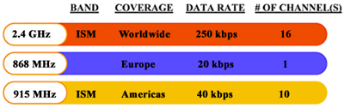

fig(2)

In a sense, ZigBee's bright future is largely due to its low data rates—20 kbps to 250 kbps, depending on the frequency band used **(Figure 2)**—compared to a nominal 1 Mbps for Bluetooth and 54 Mbps for Wi-Fi's 802.11g technology. But ZigBee won't be sending email and large documents, as Wi-Fi does, or documents and audio, as Bluetooth does. For sending sensor readings, which are typically a few tens of bytes, high bandwidth isn't necessary, and ZigBee's low bandwidth helps it fulfill its goals of low power, low cost, and robustness.

## Features and Benefits:

* Point to point, point to multi point, Mesh and peer-to-peer topologies on proprietary stack.
* Direct Sequence Spread Spectrum technology.
* Each direct sequence channel has 64K unique network addresses.
* Transmit Power: 0 dBs
* RF data rate: 250 kbps.
* Acknowledgement mode communication with retries.
* Power saving modes.
* Source / destination addressing.
* Unicast and broadcast communication.
* Analog to digital conversion and digital I/O line support.
* Default configuration for ready to use.

2.3 LCD 16 x 2 DISPLAYS:

## 

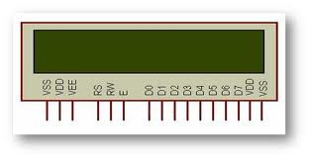

LCD (Liquid Crystal Display 16x2 LCD displays 16 characters per line and there are 2 such lines. In this LCD each character is displayed in 5x7 pixel matrix. This LCD has two registers, namely, Command and Data.

The command register stores the command instructions given to the LCD. A command is an instruction given to LCD to do a predefined task like initializing it, clearing its screen, setting the cursor position, controlling display etc. The data register stores the data to be displayed on the LCD. The data is the ASCII value of the character to be displayed on the LCD. Click to learn more about internal structure of a [LCD](http://www.engineersgarage.com/insight/how-lcd-works).

## 2.3.1 Pin Description:

|  |  |  |
| --- | --- | --- |
| **Pin No** | **Function** | **Name** |
| 1 | Ground (0V) | Ground |
| 2 | Supply voltage; 5V (4.7V – 5.3V) | Vcc |
| 3 | Contrast adjustment; through a variable resistor | VEE |
| 4 | Selects command register when low; and data register when high | Register Select |
| 5 | Low to write to the register; High to read from the register | Read/write |
| 6 | Sends data to data pins when a high to low pulse is given | Enable |
| 7 | 8-bit data pins | DB0 |
| 8 | DB1 |
| 9 | DB2 |
| 10 | DB3 |
| 11 | DB4 |
| 12 | DB5 |
| 13 | DB6 |
| 14 | DB7 |
| 15 | Backlight VCC (5V) | Led+ |
| 16 | Backlight Ground (0V) | Led- |

  Table 2.4.1 Pin description of LCD 16x2 Display

2.4 ZIGBEE TARANG BASE BOARD:

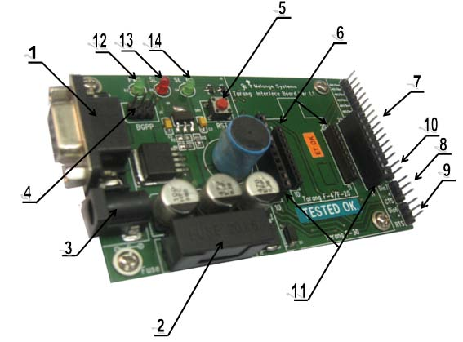

**ZIGBEE BASE BOARD:**  
 This is the base board which is used to connect the zigbee to PC directly. which is having on board 5v and 3.3 v of regulated voltage. Input to this board at DC socket is in between 7.5 and 9v of AC or DC only. This is a simple to use, RS232 to base unit made by SVSEMBEDDED for the XBee, TARANG, CC2500 products.

**Zigbee Base Board - RS232 Features:**

* Compatible with all Tarang,CC2500and XBee modules
* Built in 3V3 Voltage regulator
* On-board 3V3 &  5V level converter
* Status LED
* XBee Pins available at 2.54mm bergstrip

## 2.5 MOISTURE SENSOR:

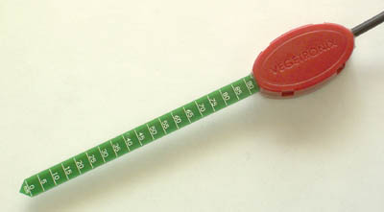

Fig 2.8VH400 Moisture sensor

## 2.8.1 Moisture Sensor:

High frequency VH400 series soil moisture sensor probes enable precise low cost monitoring of soil water content.  Because our probe measures the dielectric constant of the soil using transmission line techniques, it is insensitive to water salinity, and will not corrode over time as does conductivity based probes. Our probes are small, rugged, and low power.    
  
 Compared to other low cost sensor such as gypsum block sensors, our probes offer a rapid response time.  They can be inserted and take an accurate reading in under 1 second.

The VH400 operates at a much higher frequency and it is much more sensitive at higher VWC levels, and its curves are more linear.

Probes comes with a standard 2 meter cable.

## 2.8.2 Soil Moisture Sensor Probe Applications:

* Irrigation and sprinkler systems.
* Moisture monitoring of bulk foods.
* Rain and weather monitoring.
* Environmental monitoring.
* Water conservation applications.
* Fluid level measurements.

## 2.8.3 Soil Moisture Sensor Probe Features:

* Extreme low cost with volume pricing.
* Not conductivity based.
* Insensitive to salinity.
* Probe does not corrode over time.
* Rugged design for long term use.
* Small size.
* Consumes less than 600uA for very low power operation.
* Precise measurement.
* Measures volumetric water content (VWC) or gravimetric water content (GWC).
* Patent pending technology.
* Output Voltage is proportional to moisture level.
* Wide supply voltage range.
* Can be buried and is water proof.
* Probe is long and slender for wider use, including smaller potted plants.

**3. ZIGBEE CONFIGARATION:**

3.1 Zigbee configuration Board

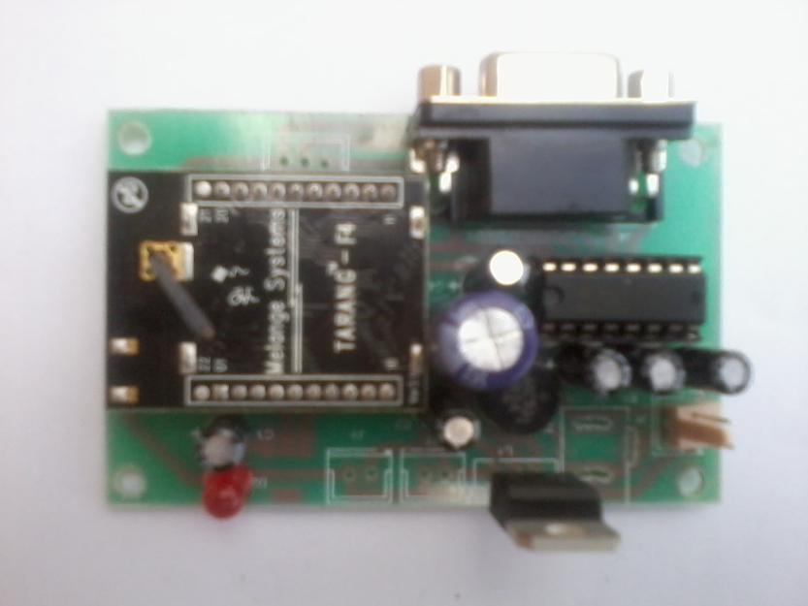

ZigBee is a short distance, simple-structured, low power, and low transmission rate wireless communication technology. It has a transmission range of 120 m and uses ISM 2.4GHz transmission frequencies. . ZigBee is expected to provide low

cost and low power connectivity for equipment that needs battery life as long as several months to several years but does not require data transfer rates as high as those enabled by Bluetooth. Tarang F4 supports serial data with: Flow Control : Hardware, none

Parity : None Data Bits : 8 Baud Rates : 1200, 2400, 4800,9600,19200, 38400, 57600,115200.

The zigbee configuration process can be view from the following URL

<http://www.youtube.com/watch?v=A6k44pcBCfA>

3.2 Zigbee configuration process:

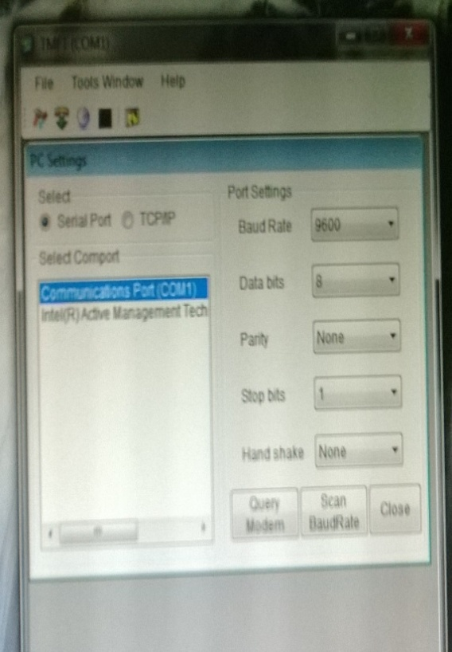 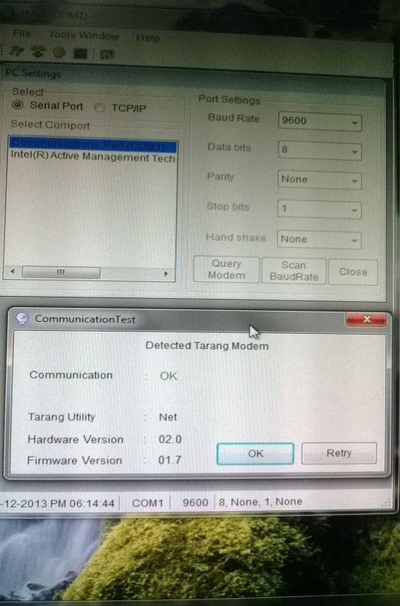 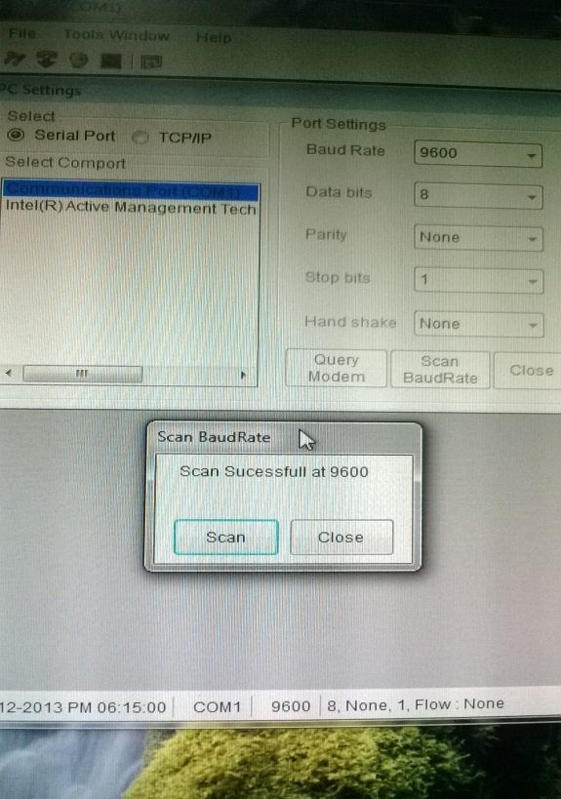 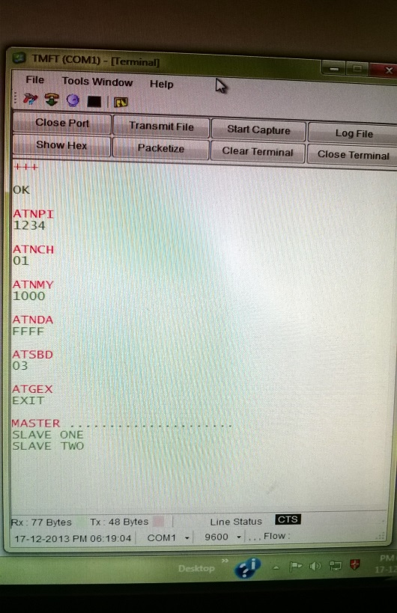

Usually TMFT.2 software is used to configure the Zigbee module to make it establish a communication link with other network. The configuration steps given in figure explain the stepwise windows for complete communication establishment.

Steps for configuring zigbee as follows

* Insert the zigbee module on to the zigbee interface board
* Connect 5 volts dc supply and serial port to the interfacing board.
* Open TMFT in the PC and do the pc settings as showing in the fig 1
* Select Serial port and choose the communication port COM1 and the port settings are as follows

|  |  |
| --- | --- |
| Baud Rate | 9600 |
| Data Bits | 8 |
| Parity | None |
| Stop bits | 1 |
| Hand shake | None |

## Click on the Query modem to know whether the Tarang module is detected or not.

* If the communication is OK then scan for the exact baud rate.
* Open terminal window and configure tarang module with commands as shown in fig. 4

## **4. BLOCK DIAGRAM**

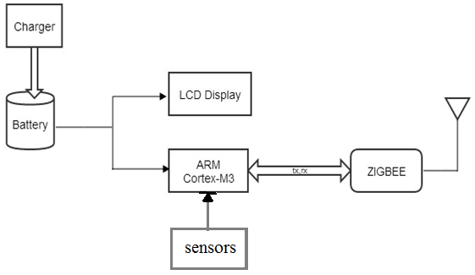

The fig showing the block diagram of a single zigbee node (MASTER). The block diagram consists of

1. Zigbee Tarang F4 module
2. Zigbee interfacing board
3. ARM Cortex M3
4. LCD Display
5. 7.4/5 v Lithium ion Rechargeable Battery
6. Sensors

**5. FINAL WORKING MODEL**

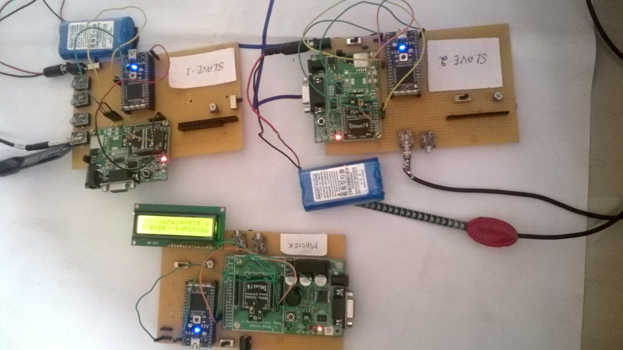

OPERATION:

The working model consists of three sensor nodes viz master and two slave nodes. The master node sends the signal to both the slaves. When master broadcast 0 on to the network, the slave 1 receives the signal, it takes the sensor value from moisture sensor and responds to the master by sending sensed moisture value. The Master receives moisture value from slave 1 and displays it on the LCD display. At a same time the master node sends the signal 1 to both the slave nodes, but only slave2 responds the signal which is broadcasted from the master node. At this moment the slave1 gets the signals reading but won’t response to it. The slave 2 collects the moisture value from the sensor and sends back to the master node which is displayed on the master’s LCD display. Thus, the whole working operation continues in this process. The slaves nodes can be more than two or three nodes which are placed at different location within the range.

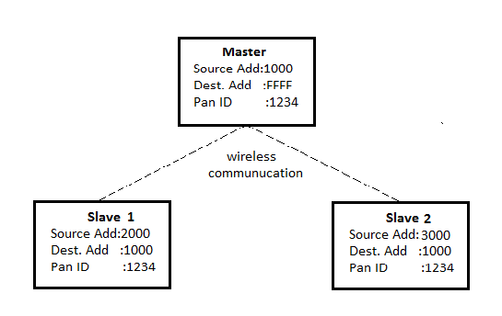

# In broadcast Network only one module will broadcast tha data to all other modules, and then each individual module will respond to that.There is no communication between individual modules except Broadcasting module.Consider the above fig,only master module will broadcast to all the slave modules then each slave module will respond to master module only.the source address of the master will be destination address to all the slaves and destination address of the master is set to broadcast address 0xFFFF.

# 6. SOFTWARE

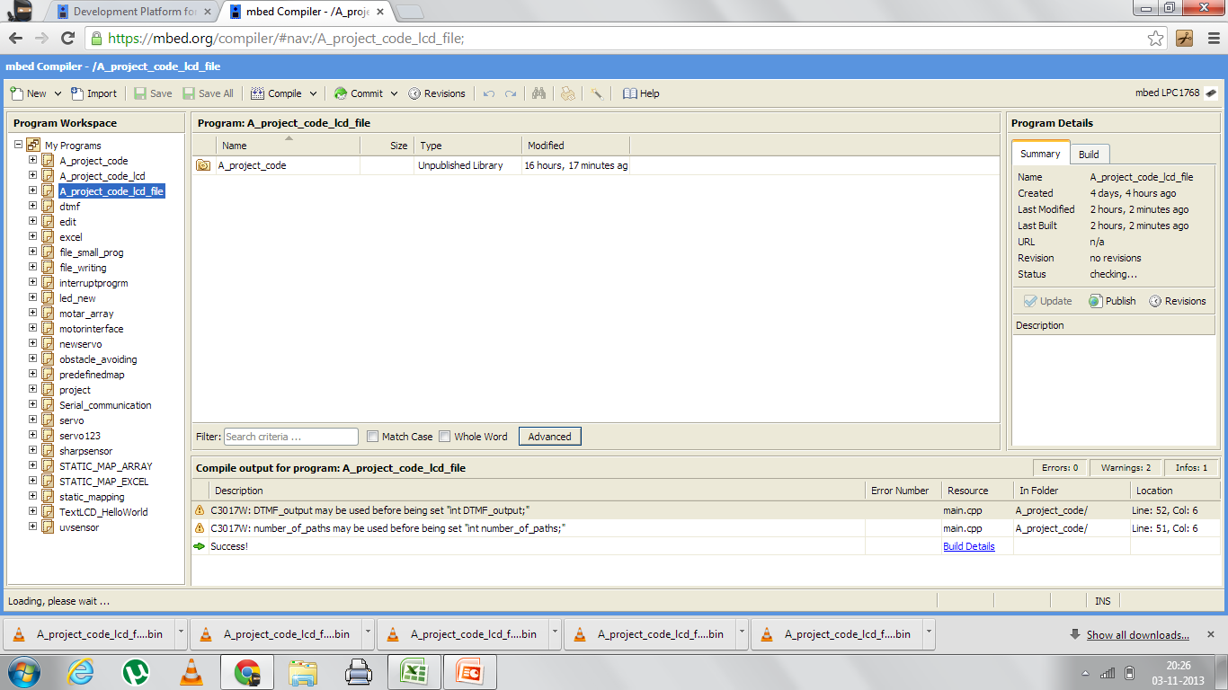

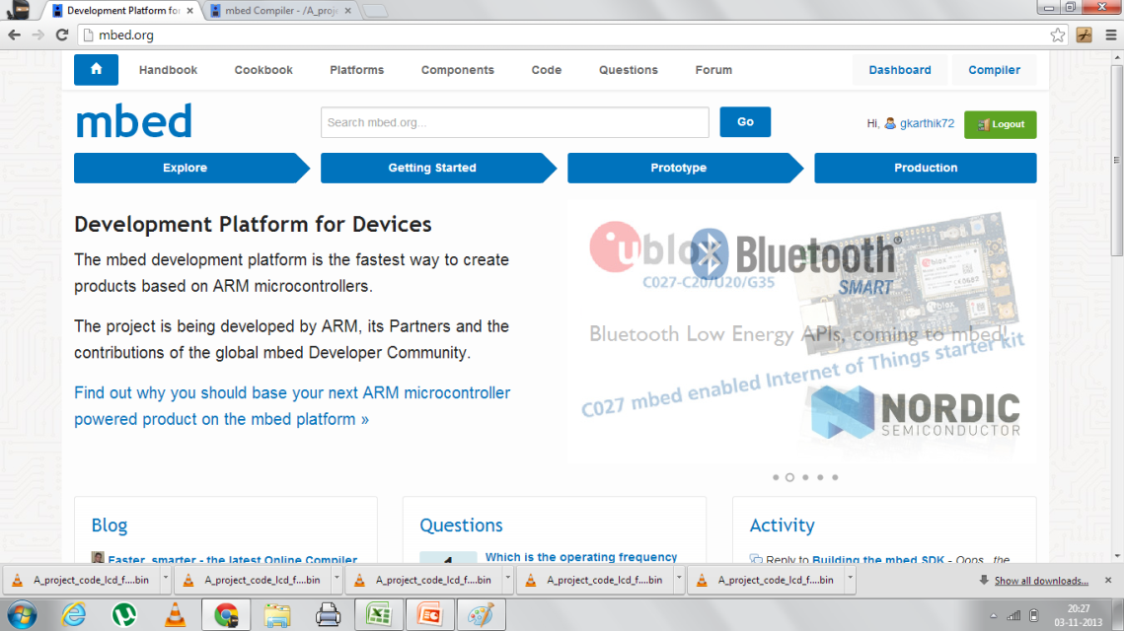

1. Code was written using **“mbed online complier” IDE** available at

“[www.mbed.org](http://www.mbed.org)”

1. Language used for coding: C++
2. Different libraries were already defined for few hardware by mbed online ide which was included in our coding
   1. **MBED.H:**
      1. Includes the basic functionalities required for programing in C++ such a printf, scanf etc…
      2. Includes libraries for different functionalities provided by the LPC1768 board such as serial pc communication, analog I/O, digital I/O, file handling libraries, interrupts etc….

# SOFTWARES EMPLOYED:

1. System Software

|  |  |  |
| --- | --- | --- |
| Sl.No | Components | Reason for selection |
| 1. | Windows XP/7 OS | Experienced usage |

1. Programming/Coding software

|  |  |  |
| --- | --- | --- |
| Sl.No | Components | Reason for selection |
| 1 | Mbed online compiler | C++ coding for ARM MBED board |

1. Application Software

|  |  |  |
| --- | --- | --- |
| Sl.No | Components | Reason for selection |
| 1. | Eagle layout editor 6.4.0 | PCB design |
| 2 | HyperTerminal | Interfacing external modules to computer(PC/Laptop) |
| 3 | TMFT | To configure Zigbee |

# 7. SCHEMATIC

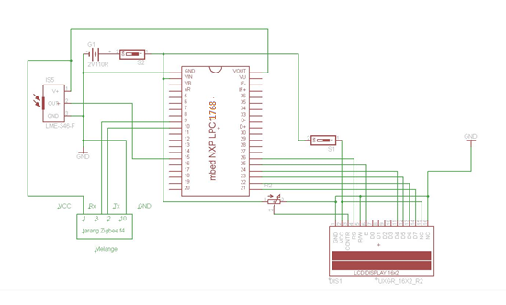

The above circuit layout was drawn using EAGLE software.

## COMPONENTS USED

* Processor: cortex M3
* Development board: LPC1768 provided by **“ARM”**
* Sensors: Moisture sensor
* Zigbee module Tarang f4
* Zigbee module interfacing board
* Servo motor and ultrasonic sensor, seen on the circuit was actually tried, but wasn’t successful. So couldn’t be presented for demo.

**8. CONCLUSION**

We proudly propose this idea to enhance the wireless communication system and obtain the knowledge of the same. This upgradement of Data Acquisition model to Low power Data Acquisition model greatly improves the power integrity. We feel glad to conclude that we have touched an effort of few technological fields, sensible utilization of zigbee based wireless sensor network, making significant use of modern wireless communication such as GSM & GPRS to name a few.

Developed system proves to be best for prototype but, still some work has to be done on product development as mentioned in future work.

**9. FUTURE WORK**

As in the conclusion where we did mention our inspiration to be the wireless sensor network system based on zigbee which can be used as a single application in our project in the field wireless communication. We would further like to improve this by prioritizing at area such as power consumption which currently feeds on battery to employing a solar cell that can power the system as well as store power for future requirements.

Once we interface the entire sensor with zigbee modules and to make a mesh network using Zigbees so that all the units communicate with each other, send the data through the main master unit to remote place. By completing the remaining work, the next process of this work is to send the data to the server which can be accessed through the World Wide Web application. Monitoring battery life for present PCB module, then to improve the battery life of the system, finally implement it in real time in the field for experiment.

# ANNEXURE-A

# DEVELOPMENT BOARD LPC 1768

# C:\Users\ANR\Desktop\DATA SHEET\MBED 1.png

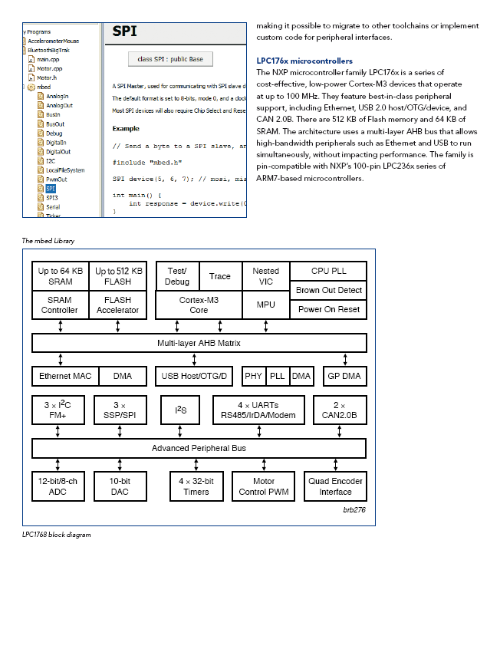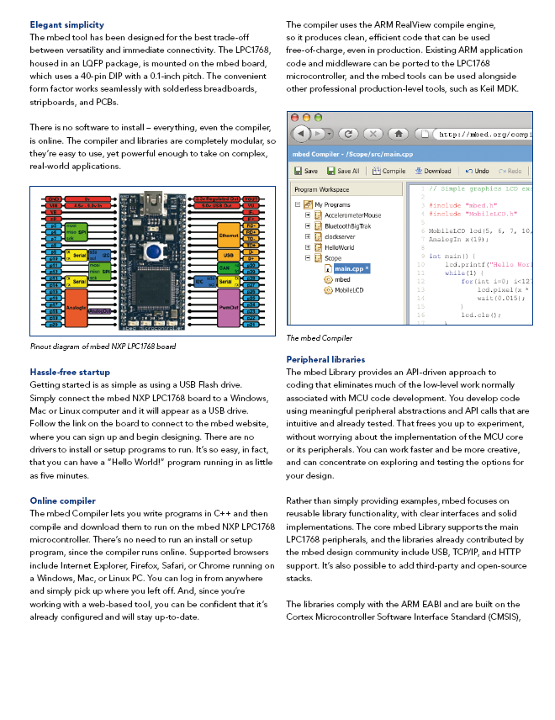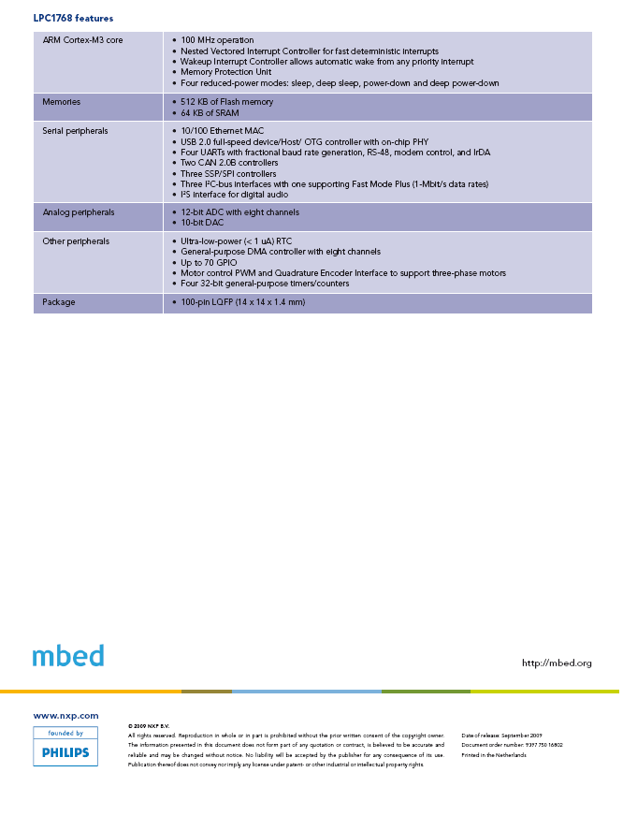

# ANNEXURE B

ZIGBEE TARANG F4

XBEEs can be used alone , without a microcontroller. This is called XBEE DIRECT. It enables projects that are truly wireless & saves space, power & cost of the project.

Tarang XBEEs have limited I/O pins. **By default all I/O pins are DIGITAL OUTPUTs** .Some of the pins can be configured as DIGITAL or Analog INPUTs.TARANG modules do not support Analog Output.

Besides transmitting data & changing state of digital pins , no logical decision can be made in XBEE Direct mode.

**TARANG Module PIN Configuration** :

[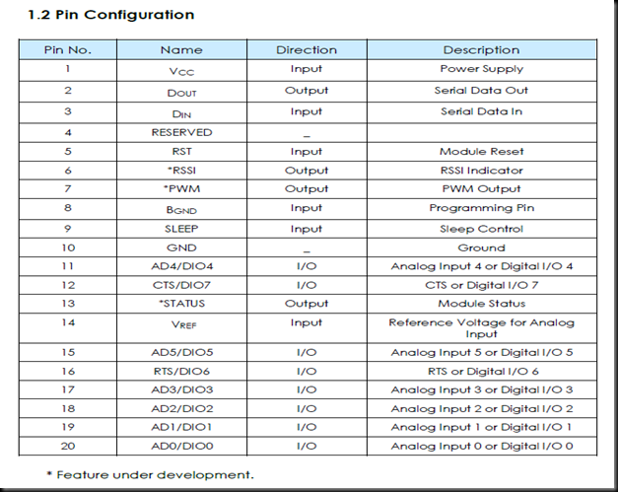](http://alselectro.files.wordpress.com/2013/09/pin_confign.png)

[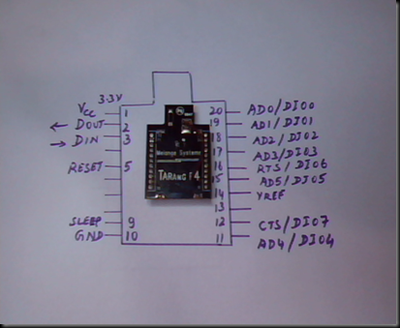](http://alselectro.files.wordpress.com/2013/09/clip005.png)

As you can see above in the pin configuration there are 8 DIGITAL I/O pins out of which 6 are multiplexed for Analog Inputs. Two of the pins are multiplexed for serial hardware handshaking signals.

CTS – Clear To Send  pin 12 /DIO7

RTS – Request To Send pin 16/DIO6.

In some cases, simple TX / RX connections are not enough to ensure your data gets delivered intact.In such cases ,Serial flow control can help make sure your data is not lost in transmission.

A transmitter raises its RTS line causing interrupt on Receiver , asking “ can I send Data “.

If Receiver accepts , it will assert its CTS line telling “ yes, you can send Data “.

Handshaking is enabled in Tarang modules using command  **ATSHS .**By default it is 0 , meaning No Flow Control.Change it to 1 ( ATSHS1) to enable handshaking.Generally handshaking is not needed unless there is another microcontroller in the project.

Note that Signal Strength RSSI debugging light (pin 6) is not yet implemented in Tarang F4.

We shall use 2 Tarang F4  modems to test XBEE Direct functionality.

Following is the set up :

[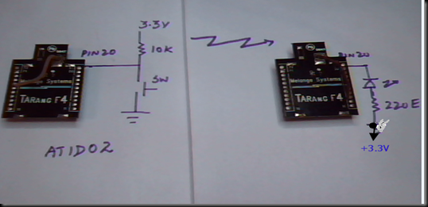](http://alselectro.files.wordpress.com/2013/09/image6.png)

Pin 20 of first modem (Digital I/O 0) is pulled high using a 10k resistor to 3.3v supply & then a switch is connected as shown.

We shall declare this pin 20 as DIGITAL INPUT using command ATID.

Enter command mode by issuing +++.

Enter command  **ATID02  ,**

**AT is the command**

**I is I/O control category**

**D0 is the I/O pin to be configured (**note it is D zero & not D letter O**)**

**& finally 2 which represents Digital Input.**

[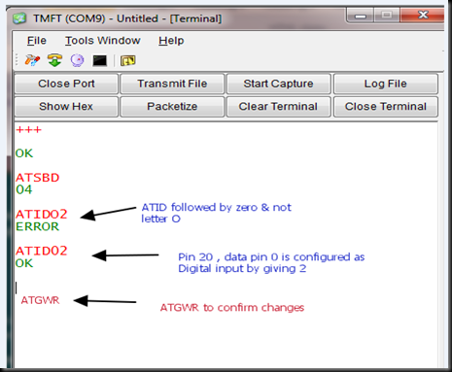](http://alselectro.files.wordpress.com/2013/09/atid.png)

Do not forget to give ATGWR command to write changes to modem.

An LED is connected as shown to the second modem’s pin 20 through a 220E resistor  to +3.3v supply.

Now if you press the switch at modem 1 , the condition of pin 20( DIO 0) is transmitted wirelessly to other end.The pin 20 of second modem goes low , lighting the LED.

# ANNEXURE C

MOISTURE SENSOR

## *VH400 Soil Moisture Sensor Probes*

|  |  |
| --- | --- |
| Our high frequency VH400 series soil moisture sensor probes enable precise low cost monitoring of soil water content.  Because our probe measures the dielectric constant of the soil using transmission line techniques, it is insensitive to water salinity, and will not corrode over time as does conductivity based probes. Our probes are small, rugged, and low power.    Compared to other low cost sensor such as gypsum block sensors, our probes offer a rapid response time.  They can be inserted and take an accurate reading in under 1 second.    The VH400 consumes more power than the VG400 series sensors because it operates at a much higher frequency, however, it is much more sensitive at higher VWC levels, and it's curves are more linear.  Probes come standard with a 2 meter cable. | VH400 - Vegetronix Soil Moisture Sensor Probe **VH400 - Soil Moisture Sensor Probe** |

### Soil Moisture Sensor Probe Applications

* Irrigation and sprinkler systems.
* Moisture monitoring of bulk foods.
* Rain and weather monitoring.
* Environmental monitoring.
* Water conservation applications.
* Fluid level measurements.

### Soil Moisture Sensor Probe Features

* Extreme low cost with volume pricing.
* Not conductivity based.
* Insensitive to salinity.
* Probe does not corrode over time.
* Rugged design for long term use.
* Small size.
* Consumes less than 600uA for very low power operation.
* Precise measurement.
* Measures volumetric water content (VWC) or gravimetric water content (GWC).
* Patent pending technology.
* Output Voltage is proportional to moisture level.
* Wide supply voltage range.
* Can be buried and is water proof.
* Probe is long and slender for wider use, including smaller potted plants.

### Soil Moisture Sensor Probe Specifications

|  |  |
| --- | --- |
| **VH400 Probe (Standard Voltage Probe)** | |
| Power consumption | < 7mA |
| Supply Voltage | 3.3V to 20 VDC. |
| Dimensions | See drawing below. |
| Power on to Output stable | 400 ms |
| Output Impedance | 100K ohms |
| Operational Temperature | -40ºC to 85ºC |
| Output | 0 to 3V related to moisture content |
| Shell Color | Red |
| Voltage Output Curves | Curves |

### Soil Moisture Sensor Probe Wiring Table

|  |  |
| --- | --- |
| Bare | Ground |
| Red | POWER:  3.3V to 20 VDC. |
| Black | OUT: (0 to 3V related  to moisture content.) |